**Module 6 JAVASCRIPT**

**Q.1 What is JavaScript. How to use it?**

**Ans:** JavaScript is a versatile programming language primarily used for creating interactive effects within web browsers. It's commonly used for web development alongside HTML and CSS.

JavaScript allows developers to add functionality to web pages, such as handling user input, modifying page content dynamically, and communicating with servers to fetch and send data without reloading the entire page.

Basic overview of how to use JavaScript:

* Internal Javascript:

You can include JavaScript code directly within HTML documents using <script> tags

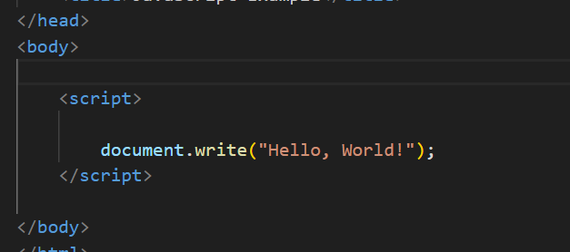

* External JavaScript files:

Instead of embedding JavaScript directly in HTML, you can also link to external JavaScript files using the <script> tag's src attribute

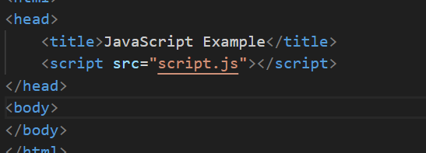

**Q.2 How many type of Variable in JavaScript?**

**Ans:** JavaScript variables are used to store data that can be changed later on.

In JavaScript, you can declare the variables in 4 ways –

* Using the 'var' keyword.
* Using the 'let' keyword.
* Using the 'const' keyword.

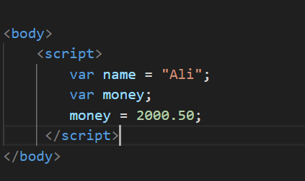

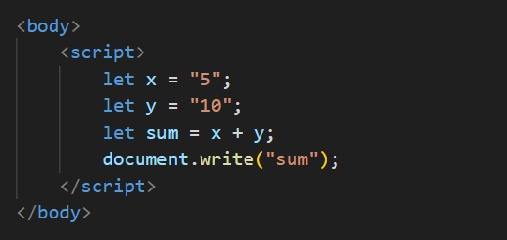

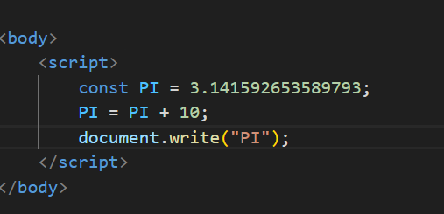

**Q.3 Define a Data Types in js?**

**Ans:** JavaScript supports several data types, which can be categorized into two main categories: primitive data types and non-data types**.**

* Primitive Data Types:

Number: Represents numeric values, including integers and floating-point numbers.

String: Represents sequences of characters, enclosed in single (' ') or double (" ") quotes.

Boolean: Represents a logical value, either true or false.

Undefined: Represents a variable that has been declared but not assigned a value.

Null: Represents the intentional absence of any value.

Symbol: Represents unique identifiers. Symbols are often used as property keys in objects to prevent naming conflicts.

* Non-Primitive (Reference) Data Types:

Object: Represents a collection of key-value pairs where values can be of any data type (including other objects).

Array: Represents an ordered collection of values, similar to objects but with integer-based indexing.

Function: Functions in JavaScript are first-class objects, meaning they can be assigned to variables, passed as arguments, and returned from other functions.

Date: Represents dates and times.

RegExp: Represents regular expressions for pattern matching within strings.

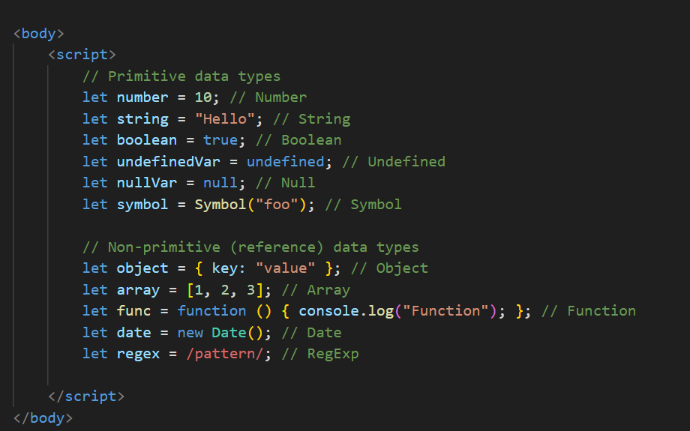

**Q.4 Write a mul Function Which will Work Properly When invoked With Following Syntax.**

**Ans:** The MUL function is a miniature of the multiplication function. In this function, we call the function that required an argument as a first number, and that function calls another function that required another argument and this step goes on.

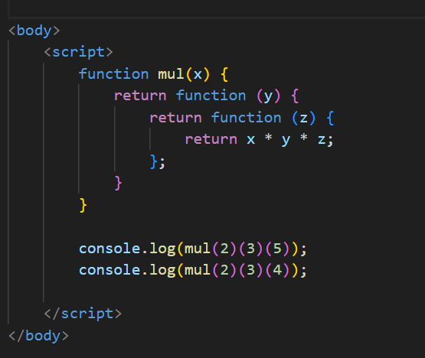

**Q.5 What the deference between undefined and undeclare in JavaScript?**

**Ans:** Undefined: It occurs when a variable has been declared but has not been assigned any value. Undefined is not a keyword.

Undeclared: It occurs when we try to access any variable that is not initialized or declared earlier using the var or const keyword**.**

**Q.6 Using console.log() print out the following statement: The quote 'There is no exercise**

**better for the heart than reaching down and lifting people up.' by John Holmes teaches us to**

**help one another. Using console.log() print out the following quote by Mother Teresa:**

**Ans:**

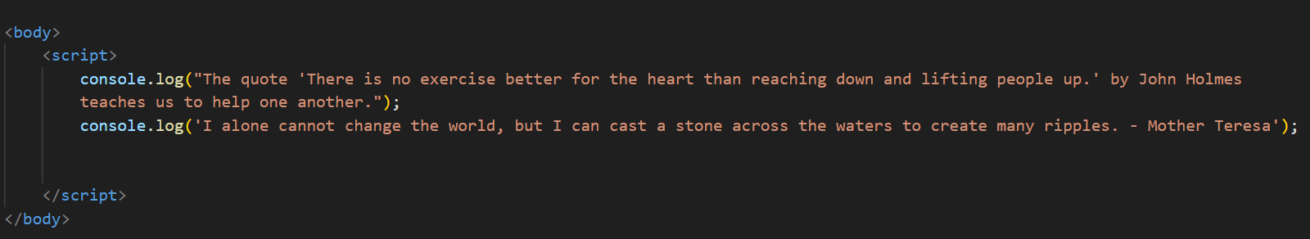

**Q.7 Check if typeof '10' is exactly equal to 10. If not make it exactly equal?**

**Ans:** The typeof operator in JavaScript returns a string indicating the type of the operand. When you use typeof '10', it returns 'string' because '10' is a string.

**Q.8 Write a JavaScript Program to find the area of a triangle**

**Ans:**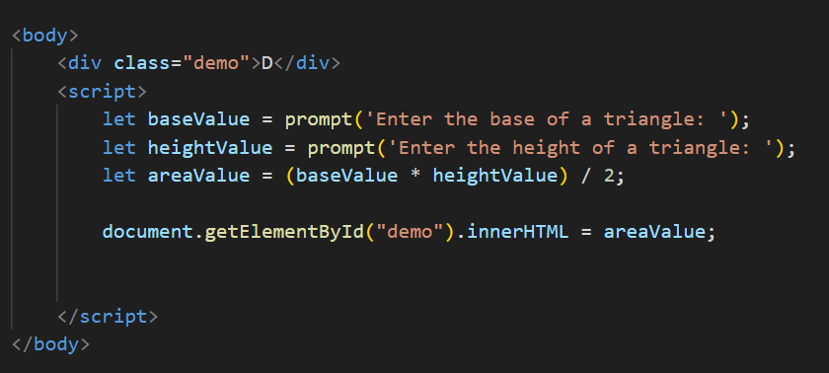

**Q.10 What is Condition Statement?**

**Ans:** A condition statement is used to execute different blocks of code based on whether a certain condition is true or false.

The most common type of condition statement is the "if" statement…

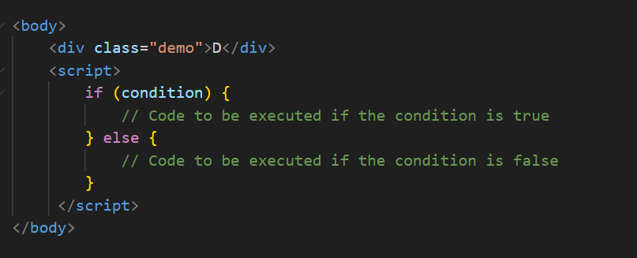

You can also have multiple conditions using "else if" statements:

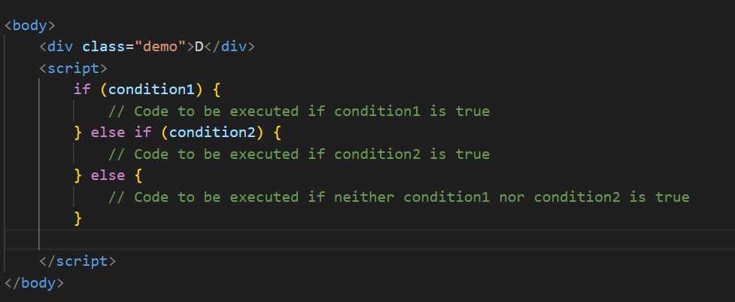

**Q.11 Find circumference of Rectangle formula : C = 4 * a ?**

**Ans:** For a rectangle, the formula to find the perimeter (the sum of all its sides) is:

Perimeter = 2 × ( length + width )

**Q.66 Find the length of a string without using libraryFunction?**

1. **What is JavaScript?**

**Ans:** JavaScript is a versatile programming language primarily used for creating interactive effects within web browsers. It's commonly used for web development alongside HTML and CSS.

JavaScript allows developers to add functionality to web pages, such as handling user input, modifying page content dynamically, and communicating with servers to fetch and send data without reloading the entire page.

1. **What is the use of isNaN function?**

**Ans:** isNaN() returns true if a number is Not-a-Number.

The isNaN() method converts the value to a number before testing it.

* // This returns true;

isNaN('Hello');

* // This returns false;

Number.isNaN('Hello');

1. **What is negative Infinity?**

**Ans:** NEGATIVE_INFINITY is a special numeric value that is returned when an arithmetic operation or mathematical function generates a negative value greater than the largest representable number in JavaScript.

1. **Which company developed JavaScript?**

**Ans:** JavaScript was developed by Netscape Communications Corporation, specifically by Brendan Eich. It was initially created under the name "Mocha" by Eich in just ten days in 1995. Later it was renamed to "LiveScript" and then finally to "JavaScript".

1. **What are undeclared and undefined variables?**

**Ans:** Undefined: It occurs when a variable has been declared but has not been assigned any value. Undefined is not a keyword. Undeclared: It occurs when we try to access any variable that is not initialized or declared earlier using the var or const keyword.

1. **Write the code for adding new elements dynamically?**

**Ans:**

1. **What is the difference between ViewState and SessionState?**

**Ans:** ViewState and SessionState are used for client-side state management and server-side state management respectively. The basic difference between these two is that the ViewState is to manage state at the client’s end, making state management easy for end-user while SessionState manages state at the server’s end, making it easy to manage content from this end too.

1. **What is === operator?**

**Ans:** The strict equality (===) operator checks whether its two operands are equal, returning a Boolean result. Unlike the equality operator, the strict equality operator always considers operands of different types to be different.

1. **How can the style/class of an element be changed?**

**Ans:** You can change the style of an element by directly manipulating its style property. For example:

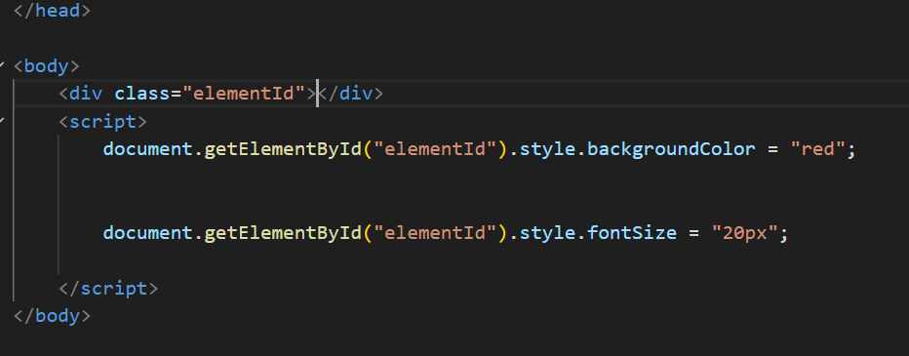

1. **How to read and write a file using JavaScript?**

**Ans:**

1. **What are all the looping structures in JavaScript?**

**Ans: 1 . for loop:**

The for loop is one of the most commonly used looping structures. It iterates a block of code a specified number of times.

for (initialization; condition; iteration) {

// code to be executed

}

**2. while loop:**

The while loop iterates a block of code as long as the specified condition evaluates to true.

while (condition) {

// code to be executed

}

**3. do...while loop:**

The do...while loop is similar to the while loop, but it always executes the block of code at least once before checking the condition.

do {

// code to be executed

} while (condition);

1. **How can you convert the string of any base to an integer in JavaScript?**

**Ans:**

1. **What is the function of the delete operator?**

**Ans:** The delete operator in JavaScript is used to remove a property from an object. It can also be used to remove elements from an array.

However, it cannot be used to remove variables or functions declared with the var, let, or const keywords.

1. **What are all the types of Pop up boxes available in JavaScript?**

**Ans: Alert Box:** The alert() method displays an alert dialog with a message and an OK button. It's primarily used for showing informative messages to the user.

**alert("This is an alert message!");**

**Confirm Box:** The confirm() method displays a dialog box with a message and two buttons: OK and Cancel. It's commonly used to ask the user for confirmation before proceeding with an action.

let result = confirm ("Are you sure you want to delete this item?”);

if (result) {

// Proceed with deletion

} else {

// Cancel deletion

}

**Prompt Box**: The prompt() method displays a dialog box with a message, an input field for the user to enter data, and OK and Cancel buttons. It's used when the user needs to input data.

let userInput = prompt("Please enter your name”, "xyz");

1. **What is the use of Void (0)?**

**Ans:** In JavaScript, void(0) is a unary operator that evaluates the expression within the parentheses and then returns undefined. It's often used in scenarios where you want to create a hyperlink that doesn't navigate anywhere when clicked.

1. **How can a page be forced to load another page in JavaScript?**

**Ans:** In JavaScript, you can force a page to load another page by changing the window.location property to the URL of the page you want to load. This can be achieved using the assign() method of the window.location object.

**window.location.href = "https://www.example.com";**

1. **What are the disadvantages of using innerHTML in JavaScript?**

**Ans:**

* The process of using innerHTML is much slower as its contents as slowly built.
* The event handlers do not get attached to the new elements created by setting innerHTML automatically.
* Either you add, append, delete or modify contents on a webpage using innerHTML, all contents is replaced, also all the DOM nodes inside that element are reparsed and recreated.
* Usually, += is used for appending in JavaScript. But on appending to an Html tag using innerHTML, the whole tag is re-parsed.

1. **Create password field with show hide functionalities**

**Ans:**

**­­­­** 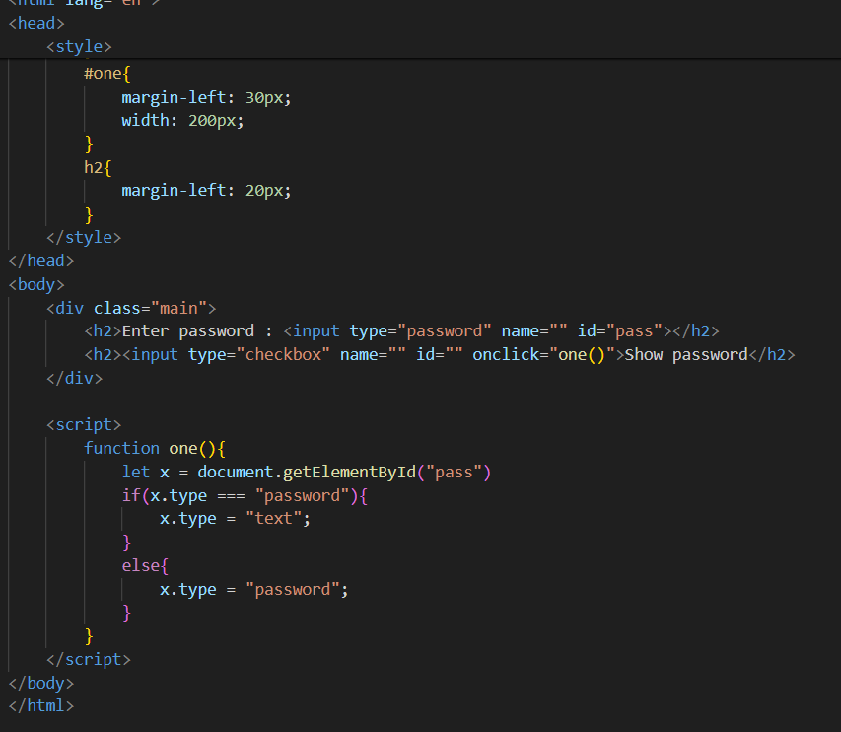

**Output:**

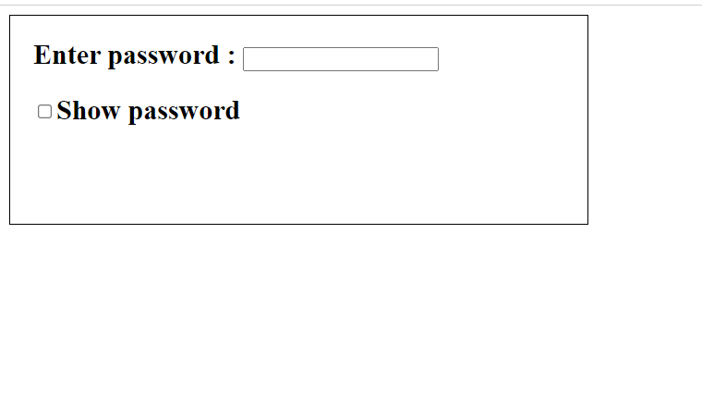

1. **Create basic math operation in JS**

**Ans:**

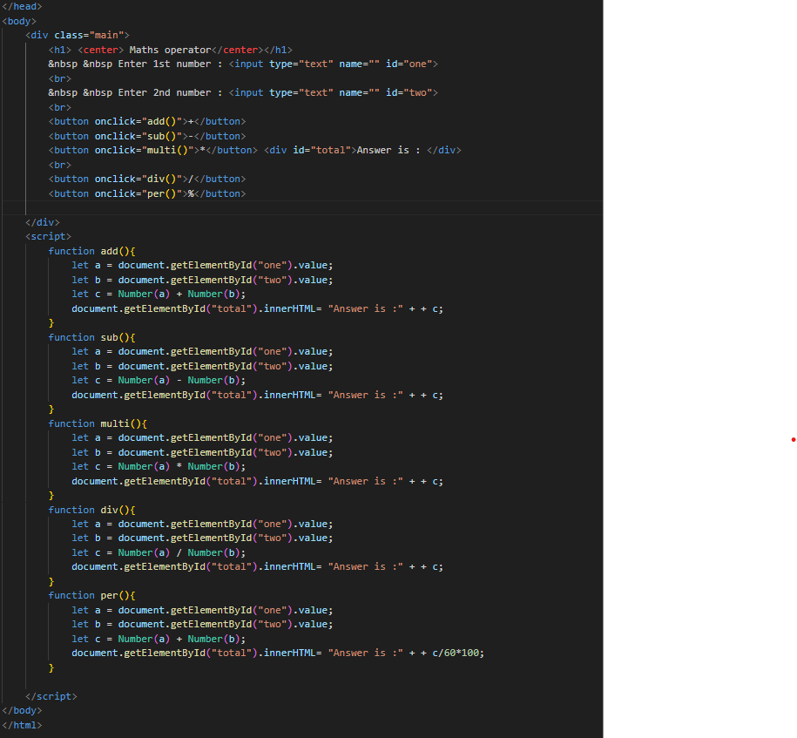**Output:**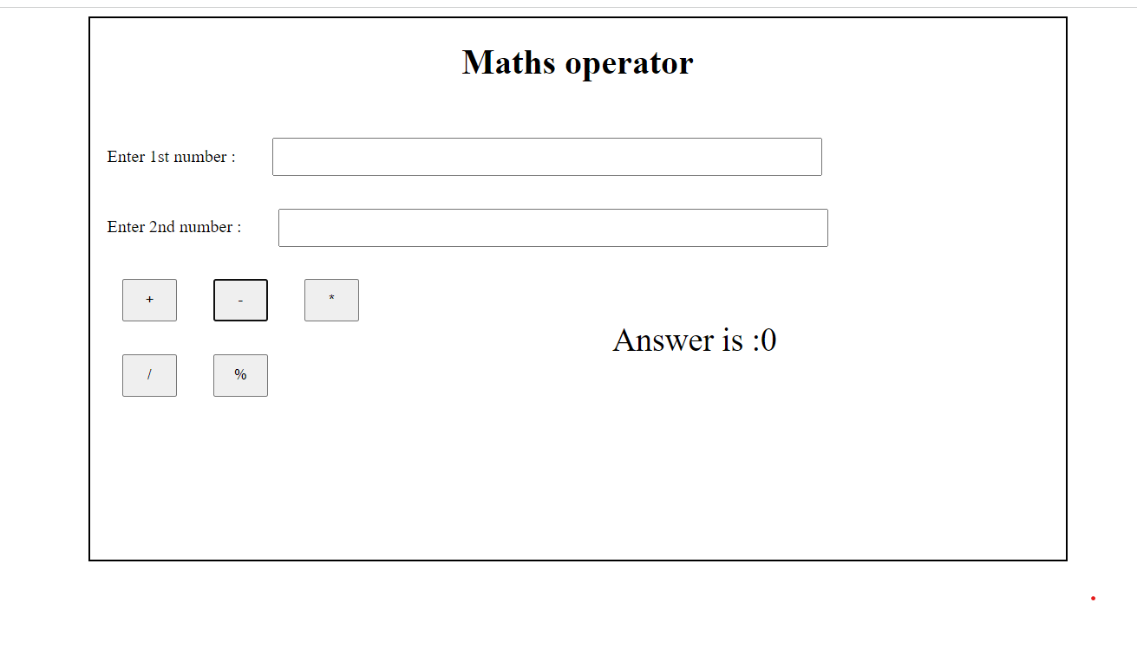

1. **Create result.**

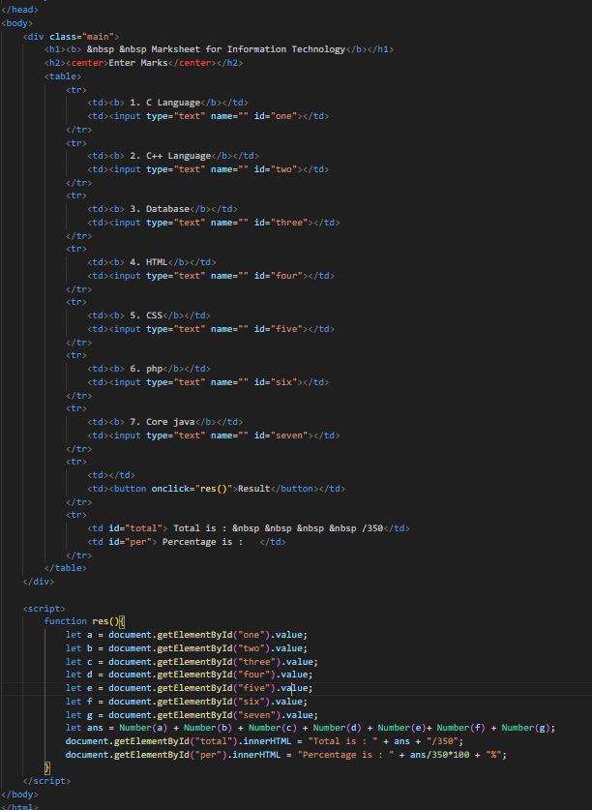

**Output:**